COAL LAB # 06

SUBMITTED TO: MAM REHANA
SUBMITTED BY: Faiqa Rafique
SAP ID: 72027
DATE:22 September,2026

TASK 01: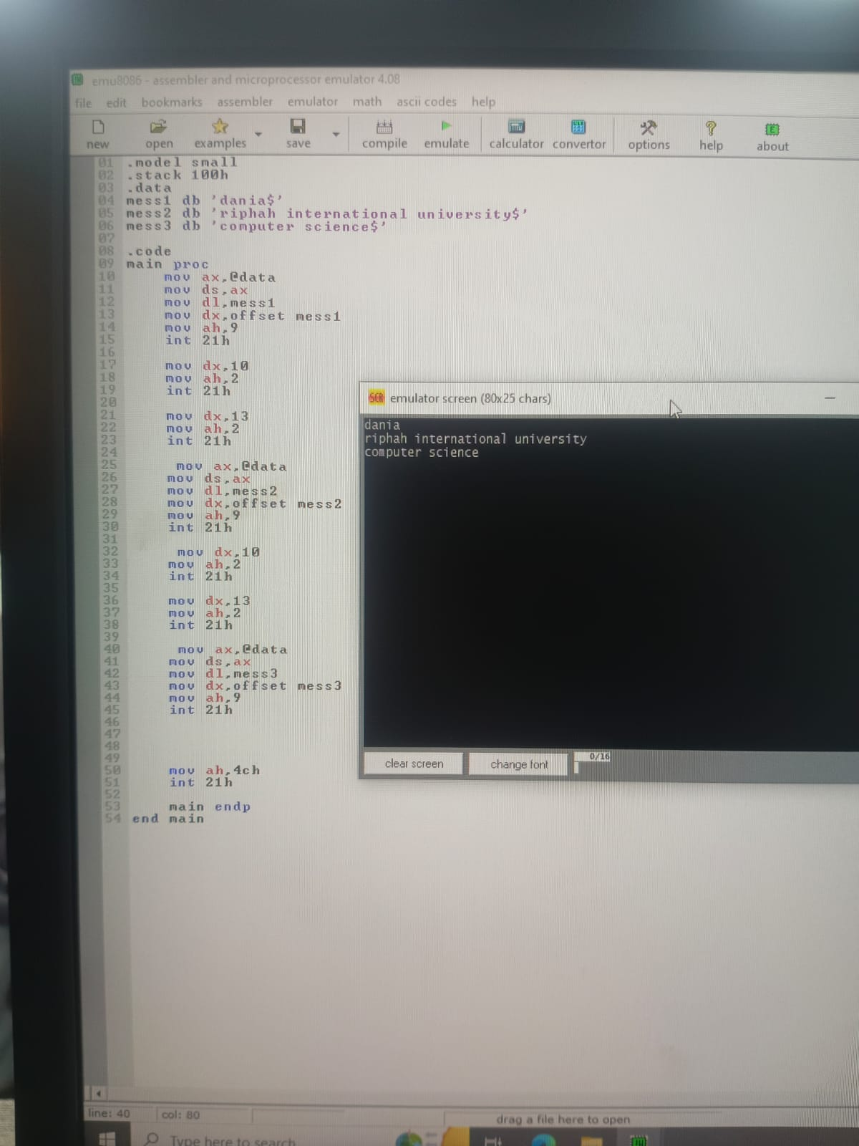

TASK 02:
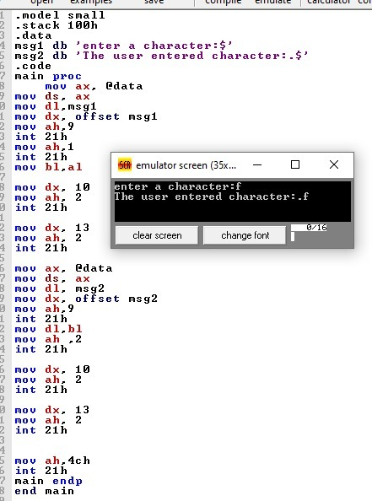

TASK 03:


